TR-069 Review
Overall review of TR-069 to understand if we can use it as a provisioning / update protocol and if yes how we would implement it.

Glossary
Primary Capabilities
End-to-end Architecture
Base Model
Proxy Management
Virtual CWMP Device
Embedded Object
Virtual CWMP Device vs Embedded Object
Object Model and Operations
Baseline Operations
Implemented by the CPE
Implemented by the ACS
Additional Operations
Implemented by the CPE
Implemented by the ACS
Session Handling
CPE Initiated Session
ACS Initiated Session
ACS Discovery
OpenTRV Commissioning
Future Use Cases for OpenTRV
Limitations

Glossary
Acronym | Expanded | Details
CPE | Customer Premises Equipment | Equipment on customer premises that is being managed by the TR-069 protocol
ACS | Auto-Configuration Server | Server that orchestrate secure auto-configuration and general management of CPE
CWMP | CPE WAN Management Protocol

Primary Capabilities
- Auto-configuration and dynamic service provisioning
- Software/firmware image management
- Software module management
- Status and performance monitoring
- Diagnostics

End-to-end Architecture

Base Model
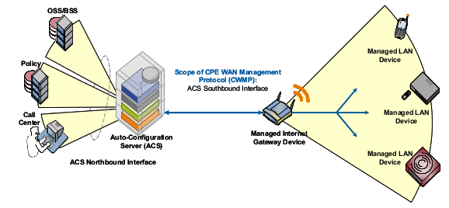
CWMP assumes that all managed devices are connected to an IP network and have a full network stack. At first glance, this disqualifies low power devices that run on a different communication protocol. However, CWMP also includes a proxy model for just that situations.

Proxy Management
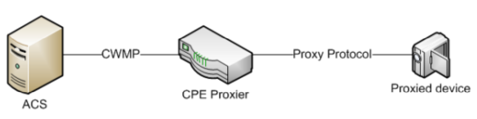
In this deployment model, the CPE Proxier acts as a bridge between the IP network and the proxied devices using a non-IP protocol (such as RF radio). This fits the device + concentrator model of OpenTRV. Each proxied device can be exposed to the ACS using one of two mechanisms:

Virtual CWMP Device
The proxier acts on behalf of the device and any virtual device operates exactly as a normal device as far as the ACS is concerned. This is done through a special data structure:
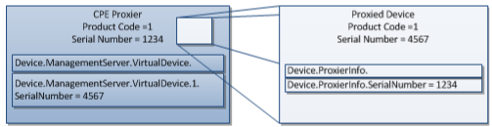

Embedded Object
The proxier exposes proxied devices through a collection of embedded objects, i.e. special data structures that holds the configuration of each proxied device.

Virtual CWMP Device vs Embedded Object
Guidelines on how to choose the implementation (the same proxy can implement a mix of both):
- The Proxied Devices that are not able to uniquely be identified by their local Proxy Protocol beyond the transport assigned address (such that they are not uniquely identified when removed and re-inserted into the Proxy Protocol network) MUST use Data Model Objects to provide proxy support.
- The Proxied Devices that do not use an interface stack to model their connectivity or features SHOULD use Data Model Objects to provide proxy support.
- The Proxied Devices that might provide no support of a reboot, factory reset and/or a download command SHOULD use Data Model Objects to provide proxy support. If such a command is needed it could be reflected in the associated Data Model, see Section I.3.4.
- The Proxied Devices that support optional RPCs such as ChangeDUState SHOULD NOT use Data Model Objects to provide proxy support.

Object Model and Operations
Device management is done through an object model, which works in a very similar way to a Java properties object: each parameter is a key/value pair with key hierarchy identified by a dot notation (e.g. Device.ProxierInfo.SerialNumber).
Configuration is done via SOAP RPC calls between the ACS and CPE. As most of them intend to modify the configuration of the CPE, they are implemented by the CPE. The ACS implements a small number of notification methods.

Baseline Operations
Baseline operations are mainly get and set operations on parameters or meta-parameters (e.g. whether a given parameter is read-only or read-write) plus generic download and reboot operations.

Implemented by the CPE
Method | Use in OpenTRV context
SetParameterValues | Modify config
GetParameterValues | Read config
GetParameterNames | Read list of accessible config parameters
SetParameterAttributes | Modify attributes of config parameters (access permissions)
GetParameterAttributes | Read attributes of config parameters (access permissions)
AddObject | Add items in list
DeleteObject | Remove items from list
Download | Download file (e.g. full config)
Reboot | Reboot the device

Implemented by the ACS
Method | Use in OpenTRV context
Inform | Initiate session
TransferComplete | Notify of completion of transfer
AutonomousTransferComplete | Notify of completion of transfer when initiated by CPE

Additional Operations
Additional operations allow more complex interactions between ACS and CPE such as scheduling and optional package management.

Implemented by the CPE
Method | Use in OpenTRV context
ScheduleInform | Ask the device to schedule communication at a later time
Upload | Ask the CPE to upload data to specified location
FactoryReset
GetAllQueuedTransfers | Request status of all queued transfers
ScheduleDownload | Request download at a later time
CancelTransfer | Cancel an ongoing or scheduled file transfer
ChangeDUState | Plugin or optional package management

Implemented by the ACS
Method | Use in OpenTRV context
RequestDownload | Enables the CPE to explicitly request a file download
DUStateChangeComplete | Notification of DU state change
AutonomousDUStateChangeComplete | Same as above when initiated by CPE

Session Handling
Communication between a CPE and ACS is done through a session mechanism. This can either be initiated by the CPE or the ACS.

CPE Initiated Session
- Bootstrap call to ACS
- Regular calls to ACS with minimum frequency
A CPE initiates a session using an Inform message. The CPE is expected to authenticate with the ACS using pre-shared credentials. Authentication methods can be:
- HTTP basic auth (HTTPS only),
- Digest auth.
The CPE user name is expected to be one of the following forms:
- <OUI> - <ProductClass> - <SerialNumber>
- <OUI> - <SerialNumber>
Password should be unique per CPE and known by both CPE and ACS.
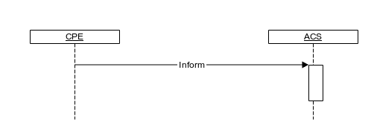

ACS Initiated Session
The ACS can issue a connection request to a CPE, in which case the CPE is expected to reply with an Inform message within 30 seconds.
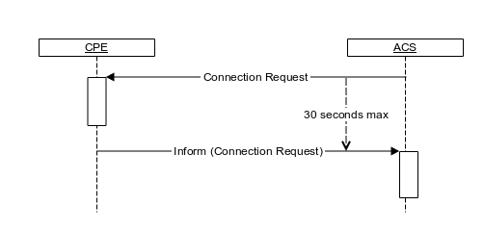
In cases where there is no inbound connection to the CPE (e.g. behind a firewall or NAT gateway), regular polling can be used by the CPE but the protocol doesn’t rely on this and proposes an alternative solution based on XMPP.
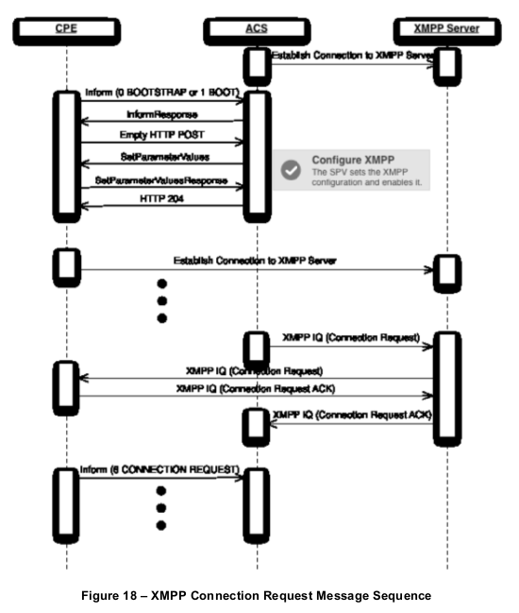

ACS Discovery
- Locally configured ACS URL
- URL obtained from DHCP server
- Hard-coded default URL if no other URL provided

OpenTRV Commissioning
The primary goal for OpenTRV using TR-069 is to simplify commissioning. One way to implement this would be through the following process:
- CPE holds a bootstrap configuration file with pre-shared password and URL of the ACS,
- CPE (concentrator) initiates connection to ACP on boot with pre-shared password,
- ACS sends download query to CPE so that the CPE downloads a complete configuration file,
- CPE restarts with new configuration file.
This process could then be improved further in subsequent releases to allow the ACS to auto-detect what devices are connected and configure each parameter individually.

Future Use Cases for OpenTRV
Implementing such a protocol could also unlock a number of future use cases for OpenTRV:
- Remote monitoring of devices,
- Remote control of devices (e.g. change target temperature based on external logic),
- Plugin, package management and software updates on the devices,
- Integrate into an on-site ACS and device management infrastructure.

Limitations
As the protocol relies on SOAP-RCP, it can be quite onerous to implement. This is mitigated by the fact that the list of essential functions is small and targets very simple operations on the CPE.
The initial mechanism to share the CPE password is not specified and feels like the weakest link in the security chain. How this is implemented with require careful consideration both in terms of security and usability for installers.

Security
Should OpenTRV implement TR-069, we will need a security review of the implementation: http://www.pcworld.com/article/2463480/many-home-routers-supplied-by-isps-can-be-compromised-en-masse-researchers-say.html

