Results of Monitoring a Vaillant ecoMAX pro 18E Boiler.
Output of boiler was measured by recording the sound of the boiler with a Rode VideoMic directional microphone. The amplified output was measured on an AC millivoltmeter and logged to a laptop PC.
Test 1a/ Boiler heating two radiators in a through lounge (all 5 other radiators in the house are turned off). The pump is a CirculatingPumps CP53 on setting 1.
The boiler output is very variable (from 19:45 until 19:55) when the boiler turns off as the circulating water is above set temperature of 75 deg C. The boiler turns on again at 20:03 and off again at 20:07. The boiler cycles for another couple of times until the 20:32 when the thermostat stops calling for heat. The pump stops at 20:40.
Notes – On these recordings there is a spike when the gas flame ignites and a similar spike when the flame extinguishes.
Test 1b/ a similar test with a Drayton Automatic Bypass Valve fitted. The ABV was set to 0.15 bar to correspond with the CF53 pump head of 2 metres on setting 1 at the ecoMAX pro 18 boiler minimum flow rate of 773.86 l/hr. The boiler output is no longer varying and the boiler is not cycling whilst the room thermostat is calling for heat.

Test 1 results – a Drayton thermostat in back (set to 18 degrees C) was used to control the boiler
Test | Outside temp deg C | front temp start deg C | back temp start deg C | front temp finish deg C | back temp finish deg C | Gas used m^3 | Time to heat hours
1a | 10 | 16 | 16 | 19 | 18 | 0.49 | 00:50
1b | 10 | 15 | 15 | 20 | 18 | 0.8 | 01:06

Test2a/ This test is with the pump on setting 1 and the ABV set to 0.15bar but only one radiator is being heated the other 6 are turned off. In this case, after the circulating water has reached 75 degrees C and the boiler has dropped to its lowest output, the boiler cycles until the room thermostat stops calling for heat.

Test 2b/ Again heating just one radiator. In this test the circulating pump setting has been increased to 2 and the ABV setting to 0.325 bar to again give the boilers minimum flow rate of 773.86 l/hr. The increased flow has resulted in fewer boiler cycles

Test 2 Results
Test | Outside temp deg C | front temp start deg C | back temp start deg C | front temp finish deg C | back temp finish deg C | Gas used m^3 | Time to heat hours | Pump setting | ABV setting bars | Comments
2a | 9 | 15 | 16 | 17 | 18 | 0.5 | 01:23 | 1 | 0.15 | 18 boiler cycles
2b | 10 | 15 | 15 | 16 | 17 | 0.51 | 01:20 | 2 | 0.325 | 12 boiler cycles

Recording setup. Rode VideoMic connected to Velleman preamplifier and UNI-T UT60A digital voltmeter. Serial connection from meter to PC samples AC millivolts. Note jar of wholemeal fusilli pasta necessary to provide microphone physical support and acoustic absorption.
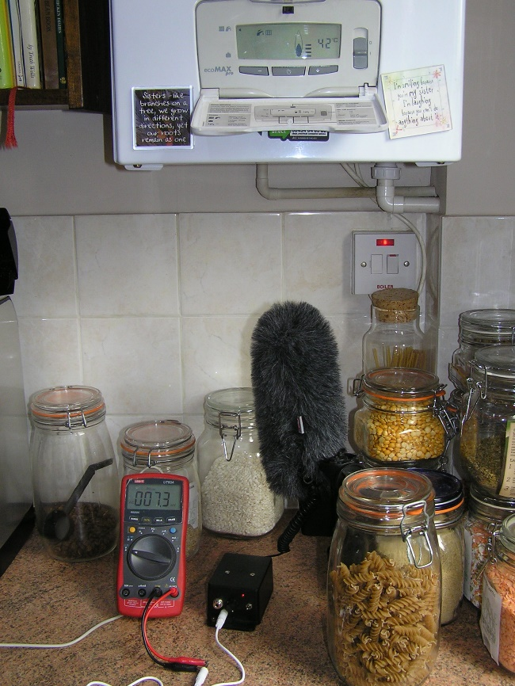
The kitchen is a working area so there are additional noises present. Some isolated sounds e.g. doors opening have been edited out of the charts. Other noises proved impossible to ignore. Below is the washing machine, the rinse and spin cycles are clearly visible (from AC voltage levels looks like the drum bearings are due for replacement).

