Y4 – Electricity
Lesson Plans
- What is Electricity
  - Understanding and identifying mains and battery
  - How electricity gets transported
  - UK pre-electricity / Developing World and alternatives to electricity
- Making Electricity
  - Understanding the concept of a turbine to make electricity
  - Fossil Fuels and Renewables
  - How electricity is transported across the country
- Circuits
- Focus on Solar (for schools with solar panels)
  - Look at the School’s solar panels, relate to consumption
  - Group activities with solar panels
- Save it, environmental awareness

Ideas for daily activities over the course:
Track weather and corresponding generation from school solar panels
Track national electricity production (eg http://electricitymap.tmrow.co/)
Give 1-2 children an OWL meter to take home for a week, and take daily readings on their consumption and report back to class on what used most/less. Alternatively, get them to take a meter reading to track 7 -day consumption (with parents help)
Make posters to put around the school encouraging others to “switch off” or “keep cold out, keep heat in” or another energy-saving action. Quite often there are competitions from utilities/energy retailers, keep an eye out.

Lesson 1. What is Electricity
  - Understanding and identifying mains and battery
  - How electricity gets transported
  - UK pre-electricity / Developing World and alternatives to electricity
Lesson Plan:
Scottish Power Lesson 2.1 “Life without Electricity” 1 hr – 1.5 hrs.
https://www.powerwise.org.uk/lesson_viewer/?id=3#slide_1
Extra resources for classroom:
Things that use electricity – at home (3 min). Lesson starter.
https://www.stem.org.uk/elibrary/resource/30647
Things that use electricity – in a theatre (2:26). Lesson starter.
https://www.stem.org.uk/elibrary/resource/30649
Video: comparing 2 Peruvian villages with and without electricity (1:36)
http://www.bbc.co.uk/education/clips/ztwrkqt
Breakdown of electricity used in our buildings:
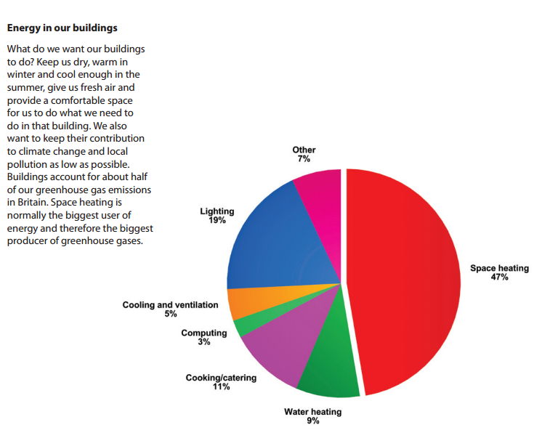
Home Activities:
- Identify items around home that are powered by battery/mains/both (table form or venn diagram)
- Write a short paragraph about what life would be like without electricity? What would be the disadvantages? Would there be any advantages?
Interactive activity: Socket overload calculator
http://www.switchedonkids.org.uk/fun-and-learning/socket-overload
Interactive Quiz: Electrical Safety At Home
http://www.switchedonkids.org.uk/electrical-safety-in-your-home
Lesson 2. Making Electricity
- Understanding the concept of using a turbine to make electricity
- Fossil Fuels and Renewables
- How electricity is transported across the country
Lesson Plan:
2 BP Lesson Plans below - (focus on fossil fuels and renewables components – not saving energy (that is lesson 4)
Need to register on BP website to access all resources:
Fossil Link: http://bpes.bp.com/primary-resources/science/ages-7-to-9/electricity/fossil-fuels-resources/#article1662
Renewable Link: http://bpes.bp.com/primary-resources/science/ages-7-to-9/electricity/renewable-energy-resources/

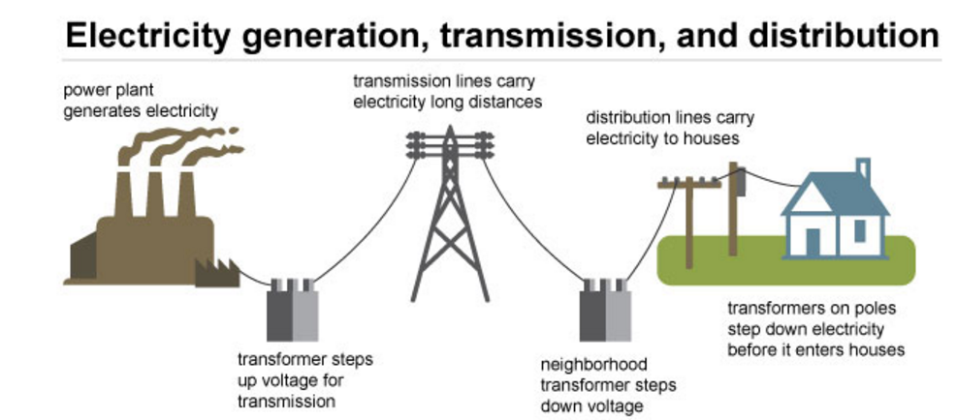

Website showing interactive map of europe, showing live electricity generation http://electricitymap.tmrow.co/
Plenty of Classroom and Home Activities supplied by BP online.

Additional Home Activity suggestions:
Power pole spotting – how many poles can you count on the way to school? Map how the electricity gets from the poles outside to the power socket in your bedroom.
Write a debate between two neighbours about a proposed wind farm/coal plant/solar farm.

Lesson 3: Solar [DRAFT]
Workshop session to investigate solar panels.
Introduce the solar panels on roof and what it does for school (powerpoint provided).
Break into groups to do solar powered activities (look at roof solar panels, hands-on experiments with solar panels e.g. direction/covering up to show effects on connected lightbulb).

Worksheet to tracking hourly generation of solar panelshttps://solar-aid.org/wp-content/uploads/2016/06/solar-worksheets.pdf

Lesson 4: Saving Electricity/Environmental Awareness
Miss Turmer to provide activities undertaken.

Assembly Ideas [DRAFT]

Assembly 1: A group/class prepares a report on the school’s carbon footprint (including energy, waste, travel, water etc) and presents it to the school, explaining what a carbon footprint is and how they have reached these results.
Assembly 2: The group highlight any areas where improvements and reductions can be made and explain how and where they intend to implement these changes. Certain classes/groups could be designated particular areas of responsibility.
Assembly 3: At the end of the term/year, a follow-up assembly to explain changes/improvements that have been made and what the energy savings are. Also, what more can be done.

Presentation on What sustainability is/what it means. • Why it is important to pupils/classes/the school/parents/home. • Perhaps allocate each of the ‘8 doorways’ to separate classes/groups to work on and report back on. E.g. One class covers water management, another food and drink (possibility to involve catering in school and have them present in follow up assembly). • Encourage the children to consider sustainability in everything they do and with their teachers, record ideas where changes/improvements could be made. • There could be follow up assembly reporting how classes got on.
Link to an international school and how they cope without or with limited electricity
Prizegiving for: Best idea for saving energy. • Best class to reduce their energy use. • Greenest pupil and staff member.

